|  |  |  |  |  |  |
| --- | --- | --- | --- | --- | --- |
| **Module No:** | 6 | **IU No:** | 1 | **Exercise No.** | 1 |

|  |  |
| --- | --- |
| **Lab Assessment Statement** | **Assignment 1 - Create sites using portlets and pages**  **Project Scenario**  Imagine that you are a Liferay web developer of "APC" Software Co., Ltd. Your company got the project to develop the "Online News Portal" to provide users with the fastest and latest news updates. You have been tasked to implement a site using portlets and pages.  As part of the initiative, you need to  **1. Setup the development environment as follows:**   * Install JDK-1.7 and setting required environment variables * Install MySQL Server (use MySQL version 5.7.19 to 5.7.22) * Download Liferay 6.2 Tomcat Bundles * Configure database settings in portal-ext.properties file * Start tomcat server and access Liferay Portal using http://localhost:8080/ * Complete required basic configurations. * Configure Liferay Server in Eclipse   **2. And, create a site using pages and portlets as below.**  A screenshot of a social media post  Description automatically generated   * Create a blank site with the site name "Online News Portal". * Choose Membership type is Open that anyone can be member of the site. * Create site pages like Home, News, About Us and Contact Us page. * Create "Welcome Message" generic portlet. * Add "Sign In" and "Welcome Message" applications to Home Page.   **Provide the site URL.**  **Provide the screen capture of the installation step, the page creates step, portlet creates step and final result.** |
| **Technical Environment** | - |
| **Guidelines** | - |
| **Duration** | 60 mins |

**Name : Syukur Sidiq Nur Alam  
Code : BDSE-0922-089/STTB**

**1. Setup the development environment as follows:**

* Install JDK-1.7 and setting required environment variables

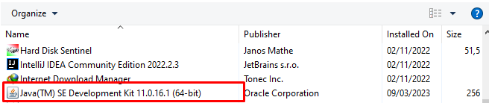

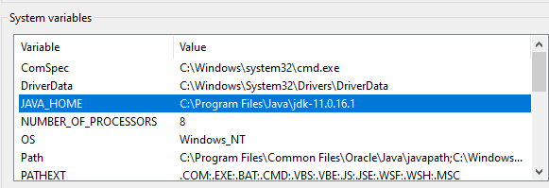

* Install MySQL Server (use MySQL version 5.7.19 to 5.7.22)



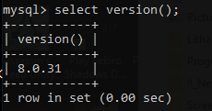

* Download Liferay 6.2 Tomcat Bundles (using 7.4.33 version)



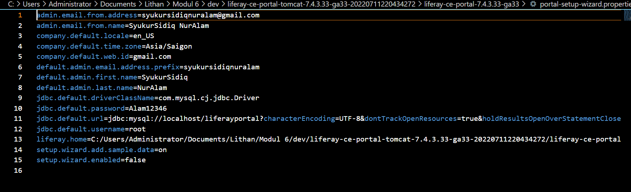

* Start tomcat server and access Liferay Portal using <http://localhost:8080/>



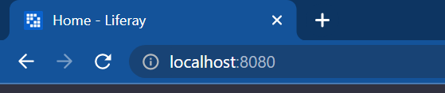

* Complete required basic configurations.

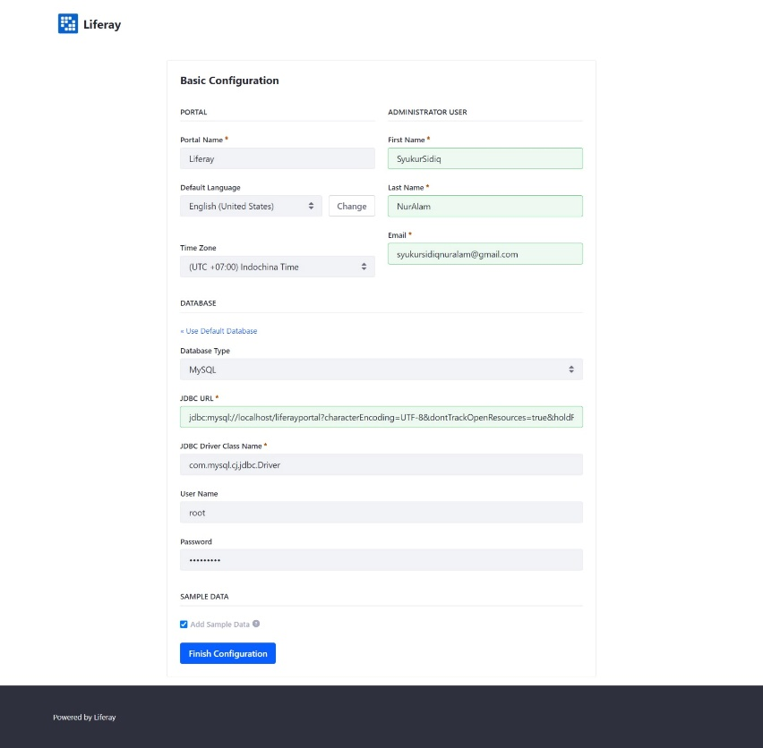

* Configure Liferay Server

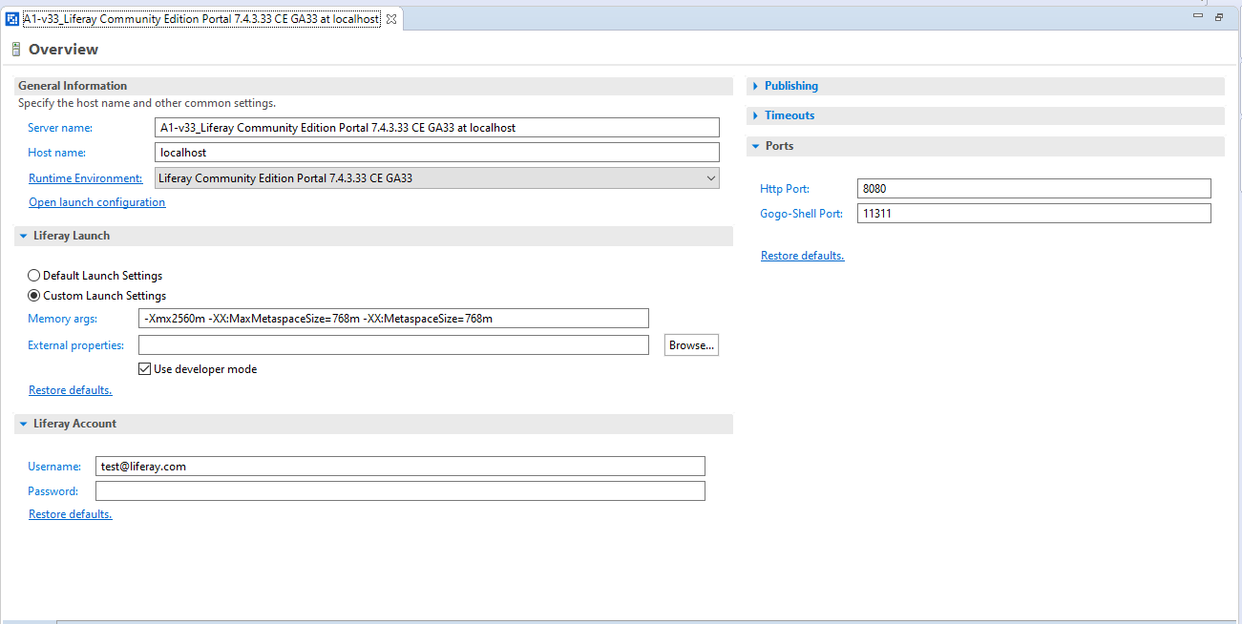

**2. And, create a site using pages and portlets as below.**

* Create a blank site with the site name "Online News Portal".

Go to control panel and click sites

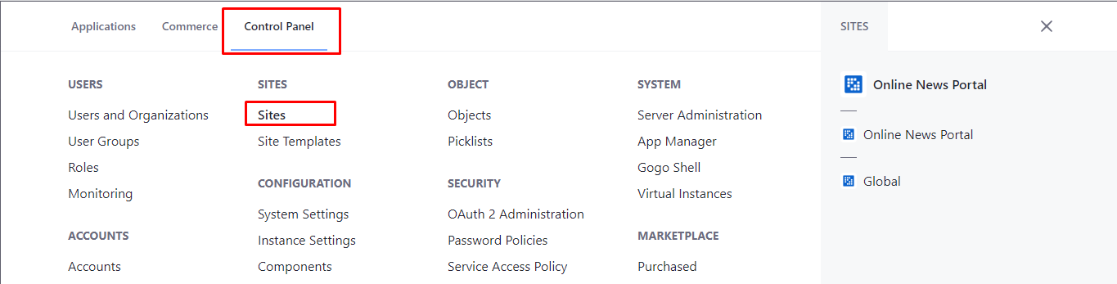

Click add

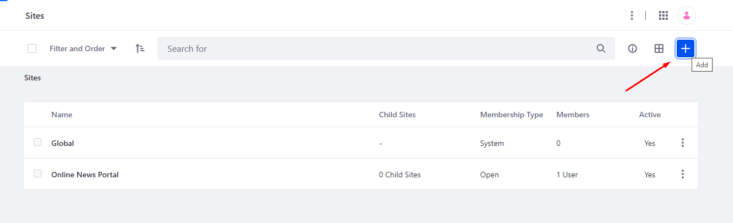

Choose a blank Site

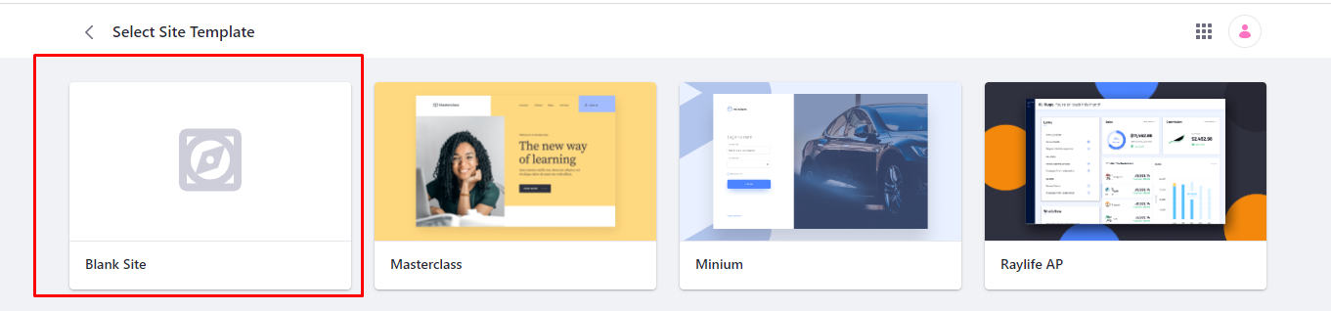

Name : Online News Portal

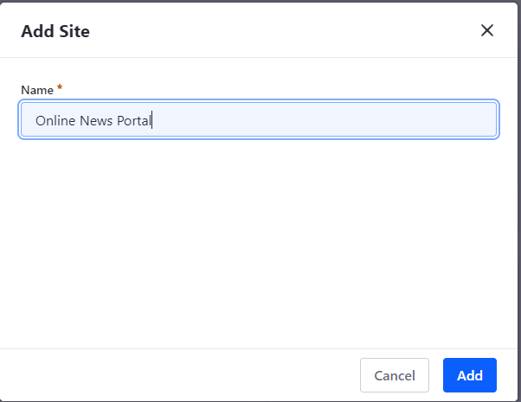

* Choose Membership type is Open that anyone can be member of the site.

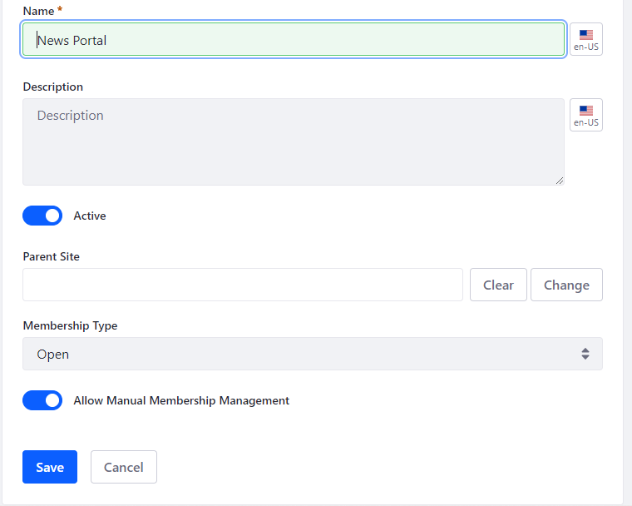



* Create site pages Home, News, About Us and Contact Us page.

Go to site builder and click Page

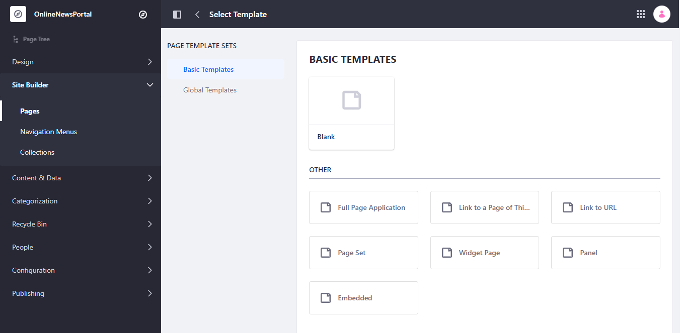

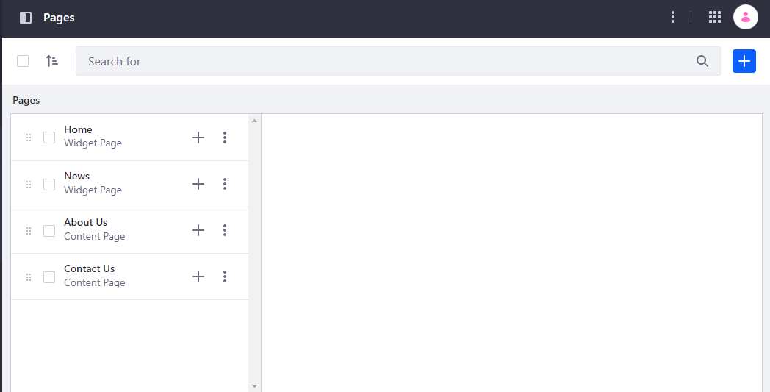

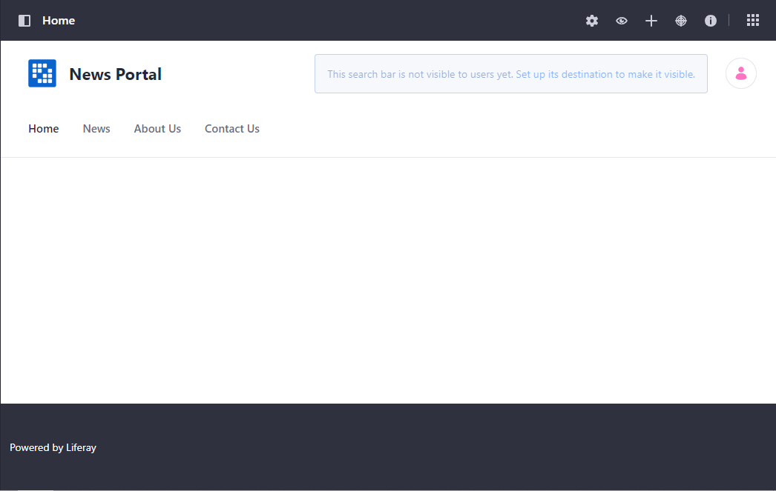

* Create "Welcome Message" generic portlet.

Make new module project

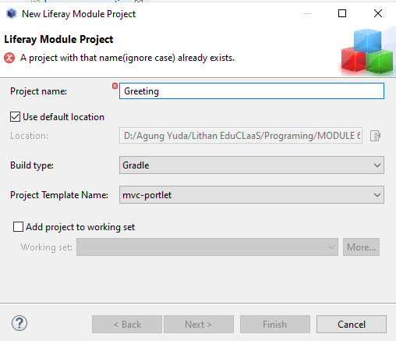

After that go to resources select language properties

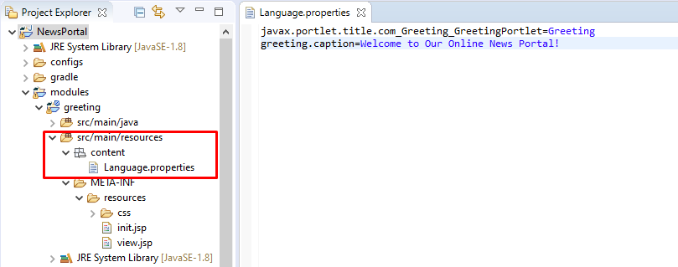

After that on gradle task, first click build and wait. When finish click deploy

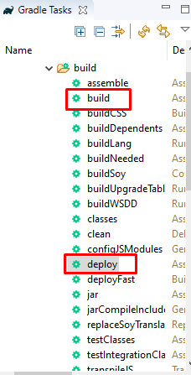

You go to the workspace folder and copy inside the folder deploy jar extension and paste on the server tomcat in deploy folder

* Add "Sign In" and "Welcome Message" applications to Home Page.

